Mega InTech

Internship Report

Of

Shovon

# 

# Tasks done over 1-year duration:

## Code Conversion:

1. Learning Existing Algorithm Code:   
   This involved a deep dive into the existing codebase for the activity recognition algorithm. Understanding how it functioned, its components, and the logic behind it was a crucial first step.
2. Converting Code for New Sensor:   
   With the introduction of the new ImpactSense sensor, it was essential to make the existing code compatible with the data generated by this sensor. This required thorough analysis and modification of the codebase.
3. Code Streamlining:   
   The initial code was dispersed across four separate MATLAB files, making it cumbersome to work with. To enhance usability, these files were integrated into a single consolidated file. This consolidation made it much easier to run, test, and debug the code.

## ImpactSense Sensor Feedback:

1. Device Status Indicators:  
   Recognizing the absence of indicators or LED lights on the ImpactSense sensor was crucial. This was leading to issues where the sensors were inadvertently left turned on, causing battery depletion. Identifying this problem and communicating it to the team was essential.

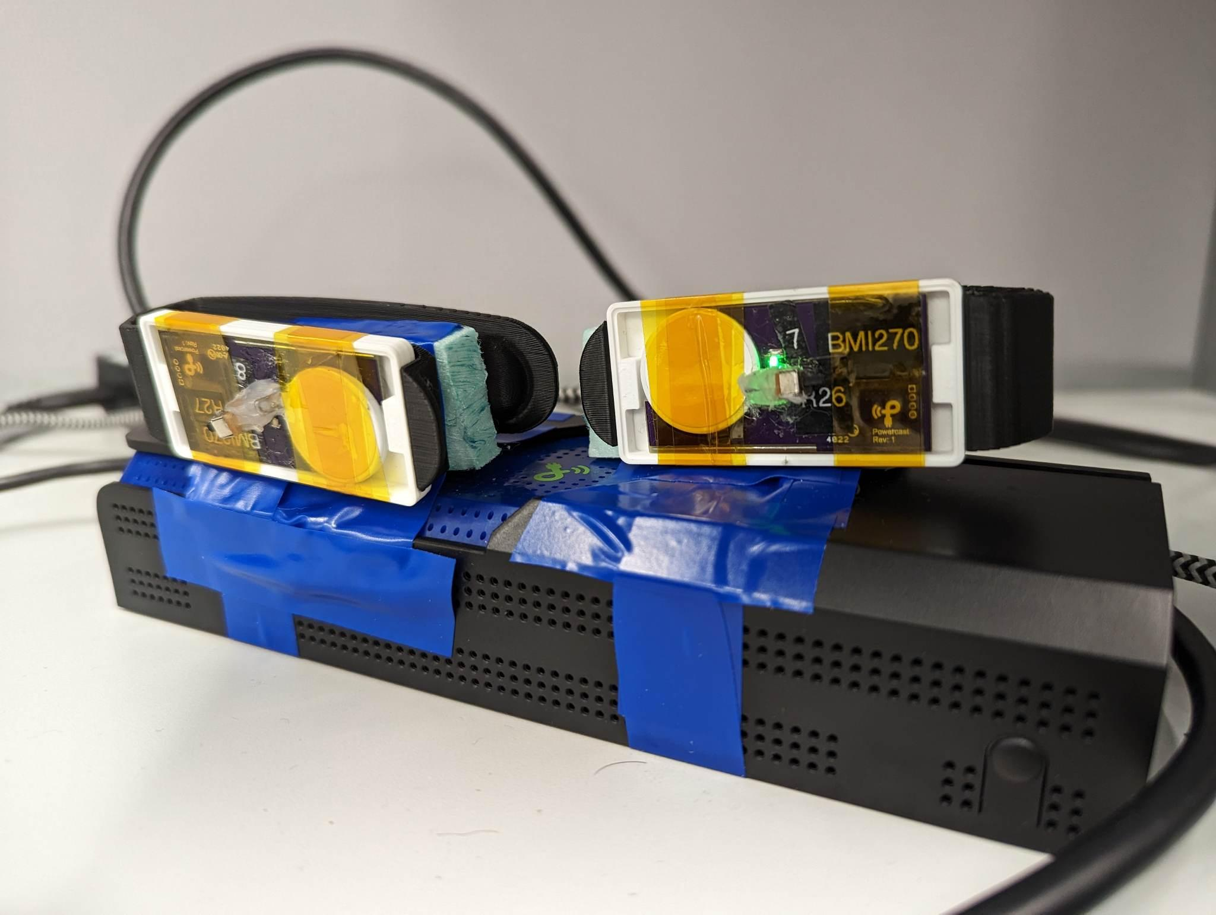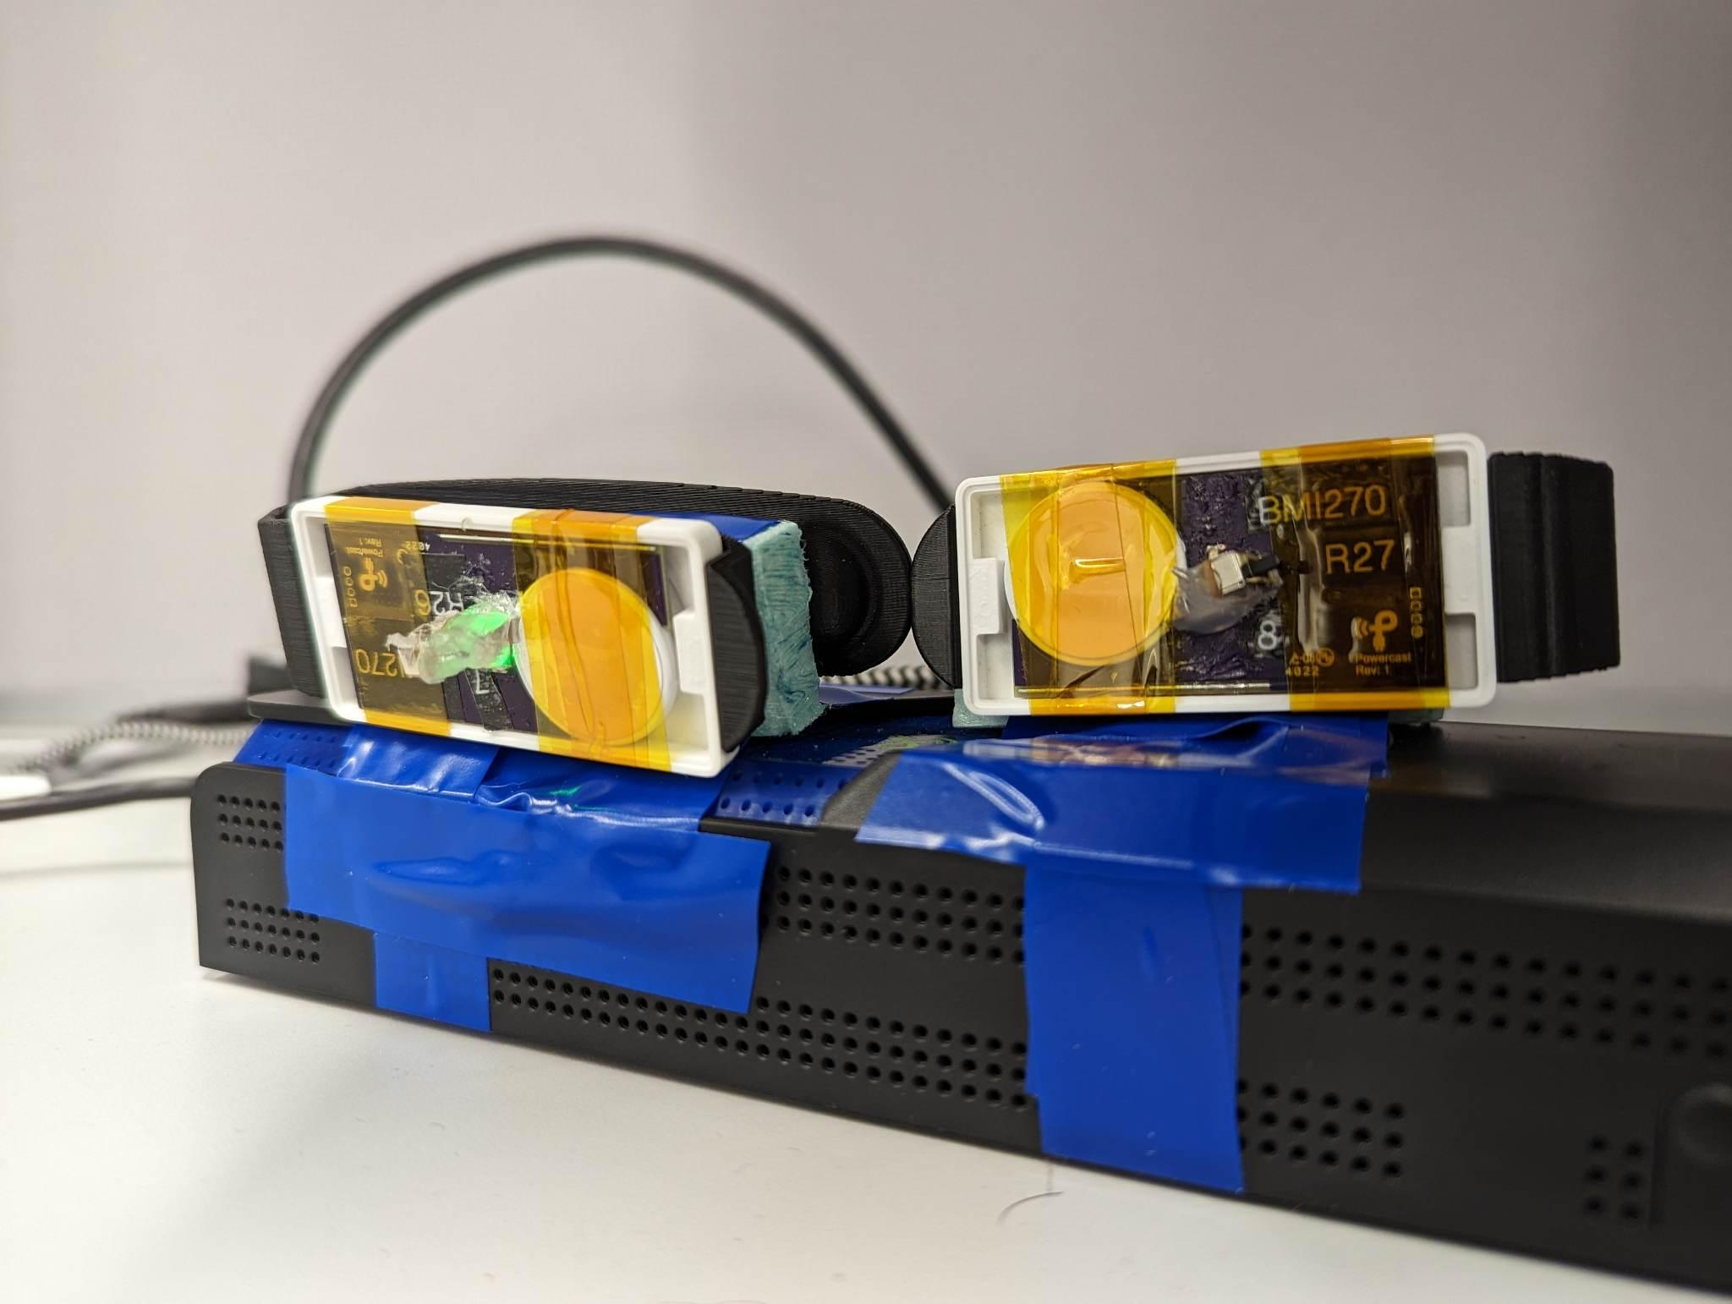

In the above pictures it can be seen that the L1 (BMI270) device’s LED glows when it is near either of the mounting positions of the charger (even when it is turned off).

1. Sensor Recharging Challenges:   
   Addressing difficulties in determining whether the sensors were actively charging or not was another important task. Finding a solution to this problem contributed to improved sensor management.

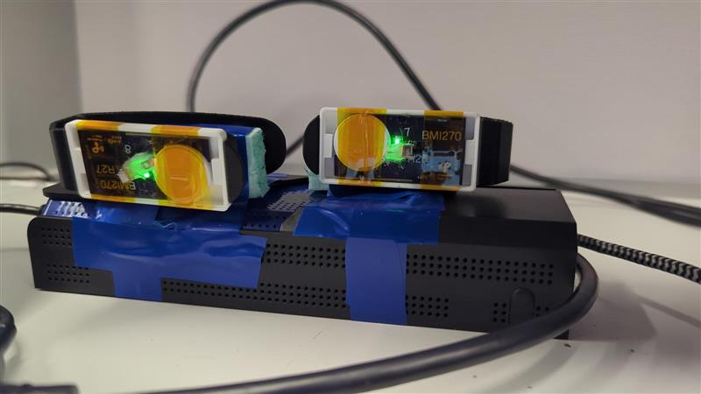

The L1 device’s LED glows when it is near either of the mounting positions of the charger (even when it is turned off).

1. Packet Loss Investigation:   
   Investigating and reporting issues related to packet loss during data collection was a critical aspect of ensuring data accuracy and reliability.

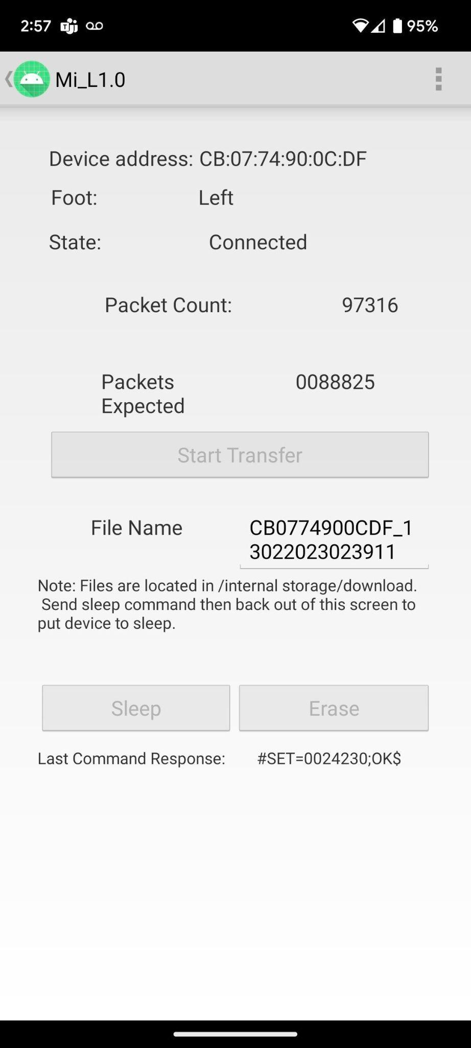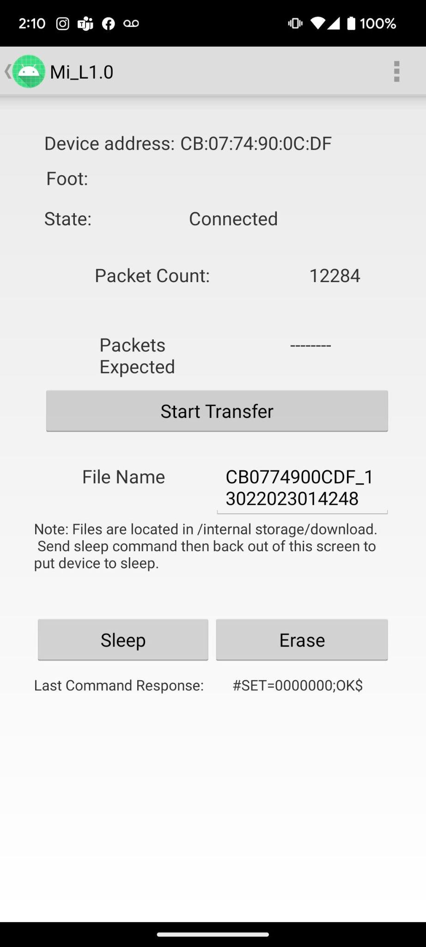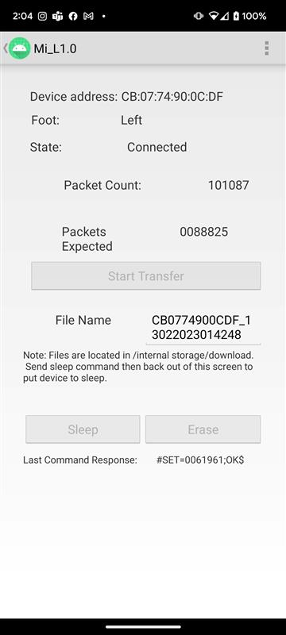

1. App Stability Analysis:   
   Identifying instances where the app crashed during data transfer, especially on specific Android versions, was vital information. This helped in resolving compatibility issues and enhancing user experience.

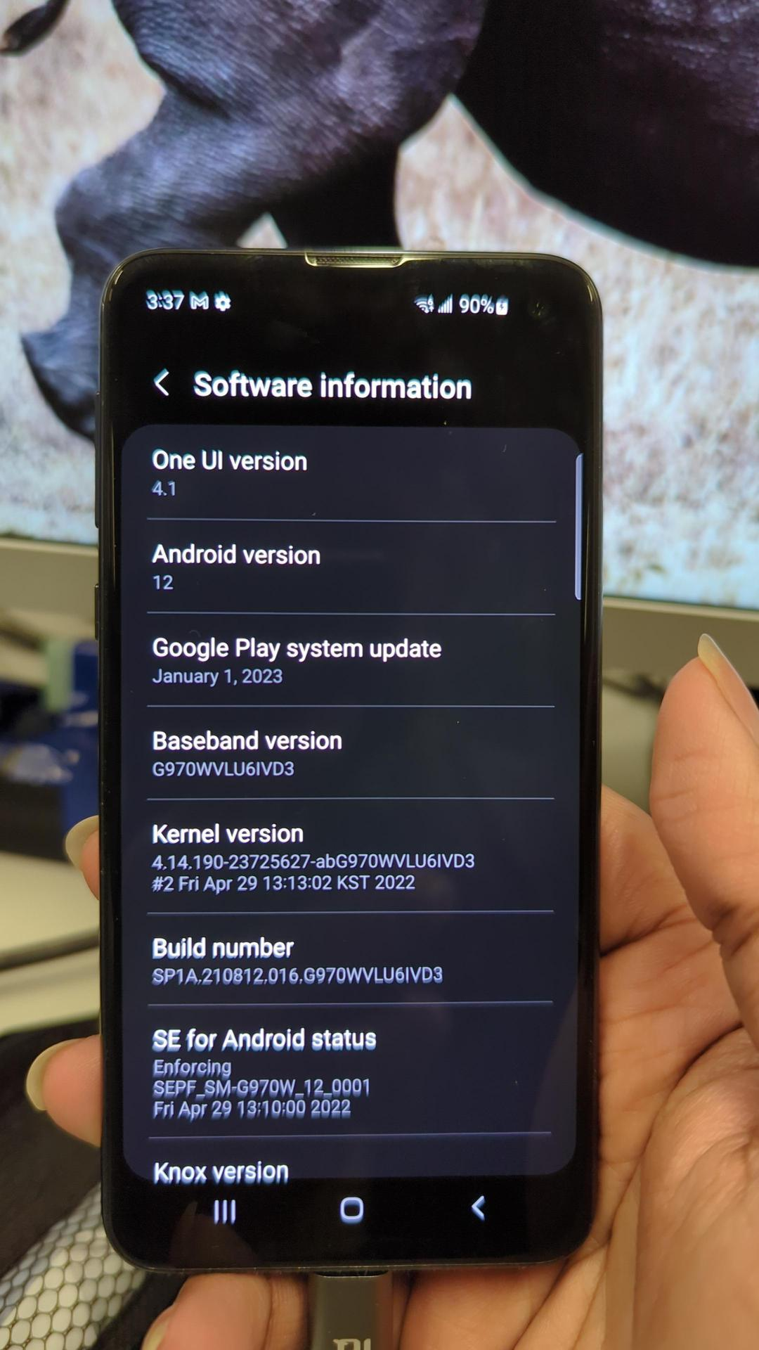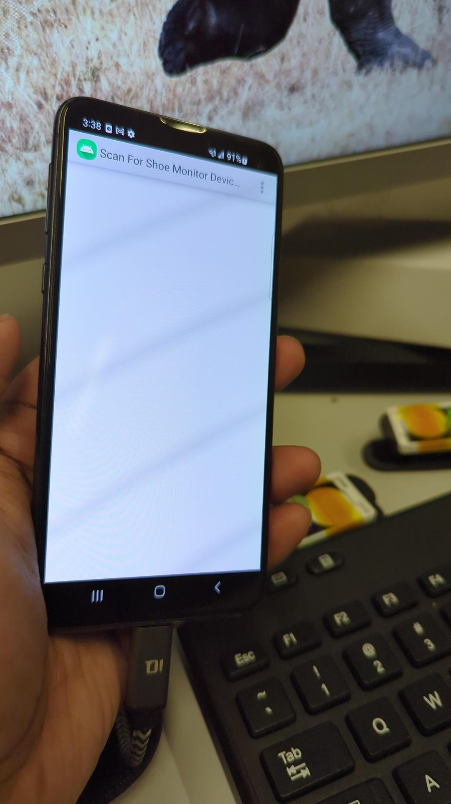

Tried to transfer using the Samsung S10e (Android 12), the phone does not list the devices on the app.

Now the app is running great on Samsung A8 Tablet and Google Pixel 7, both running Android 13.

## Data Collection:

1. Extensive Data Gathering:  
   Collecting a diverse set of data, including three-speed walking data and various physical activities, was a time-consuming but necessary task. This data served as the foundation for developing and testing the activity recognition algorithms.
2. Verification of consistency between ImpactSense and Gaitup:

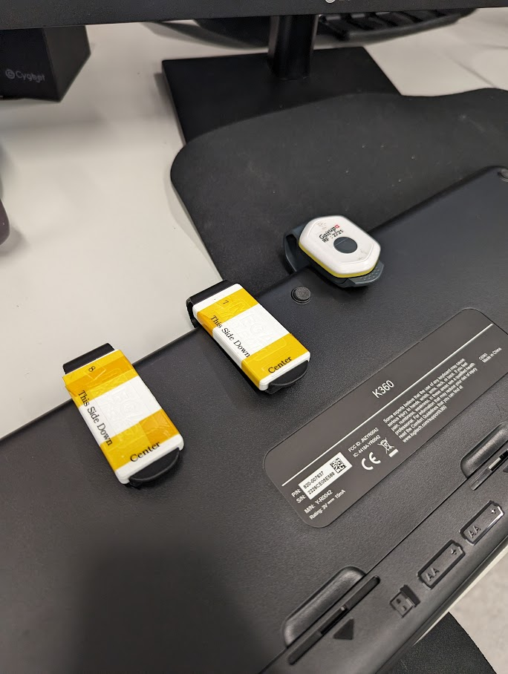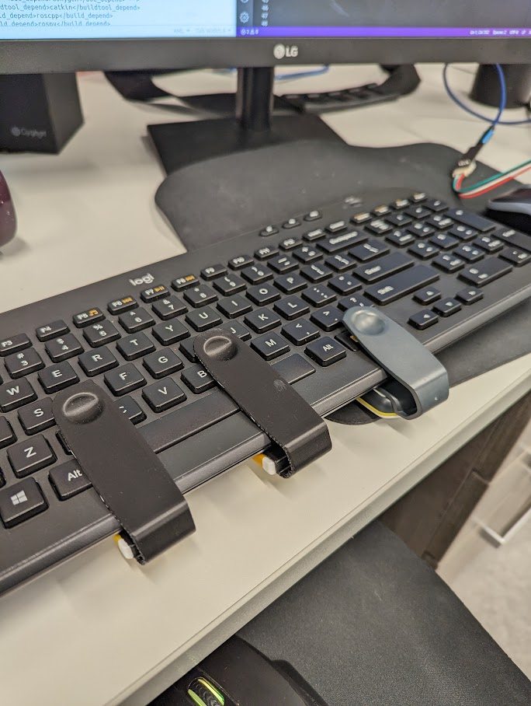

Here two ImpactSense sensors and Gaitup were clipped with a hard rigid body (keyboard in this case). The keyboard was then swang in each of the three axes and then a random combination of the axes for testing out the consistency of the sensors. The data were passed to Mohammad for verification.

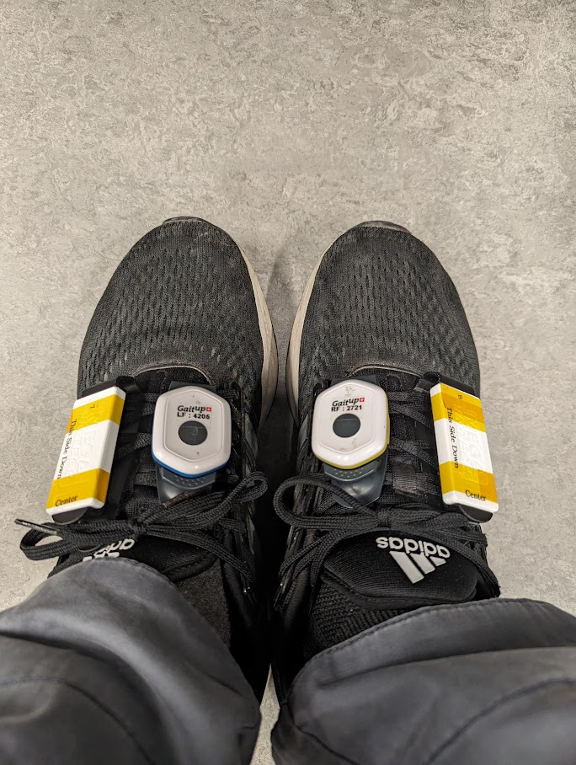

Another verification test was conducted where both types of sensors were clipped with the shoelaces and the activities like walking, stairs ascent and stairs descent were performed by the participants so that side by side results can be compared.

1. Channel Correction:   
   Identifying and rectifying a channel error in the data collection process, switching from Gyro-X to Gyro-Y, was crucial for ensuring the accuracy of stride data.

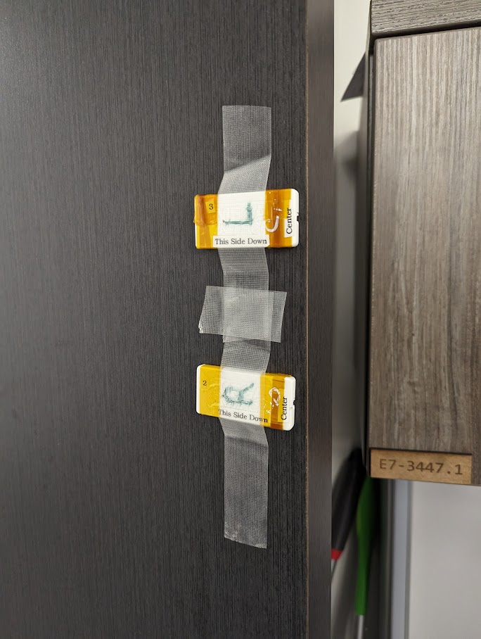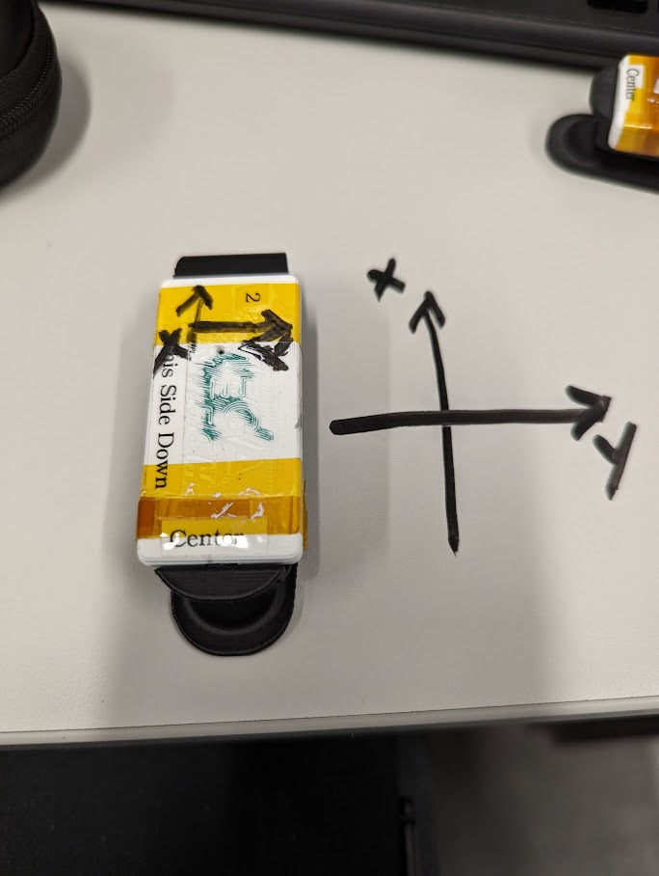

As the graphs given by the strides were giving unexpected results, the IMU sensor was tested by taping it to the door and moving it after changing its orientation. Eventually the actual orientation of the axes present in the sensor were identified.

Afterwards, the channel was changed to GyroY from GyroX because it gave most of the motion data that was needed to identify the activities.

It is essential to also note that an application of fixing the orientation using PCA was also discussed in the team meetings but later on it was not implemented as it was found that the results without using the PCA was enough to distinguish the strides.

1. Transition to Python:   
   Collaborating with Ranjani to transition the code from MATLAB to Python opened up new possibilities and improved compatibility with other tools and libraries.
2. Filter Design:   
   The design and implementation of filters in Python to replicate MATLAB results were essential for ensuring consistency in the analysis and results between the two platforms.
3. Data Labeling for Machine Learning:   
   Manually labeling the collected data for training a machine learning model, specifically an SVM (Support Vector Machine), was a critical step in creating a robust recognition system.
4. Threshold Tuning:   
   Adjusting thresholds in both MATLAB and Python for peak detection and stride segmentation ensured that the algorithms consistently identified activity changes.

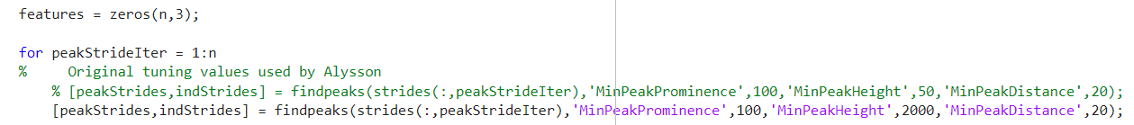

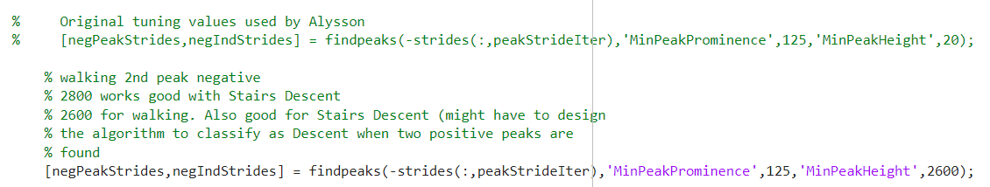

In the above screenshots it can be seen that the values previously used by Alyson differs a lot from what is being used now. The findpeaks() function was used to detect the peaks and the threshold values required for detection were fine-tuned manually after close examination of strides of multiple participants.

MinPeakHeight is the main parameter that was tuned for accurate peak detection.

1. Sensor Noise Mitigation:   
   Implementing various noise reduction techniques, such as taping sensors and adjusting their placement on shoes, was crucial for improving the quality of the collected sensor data.

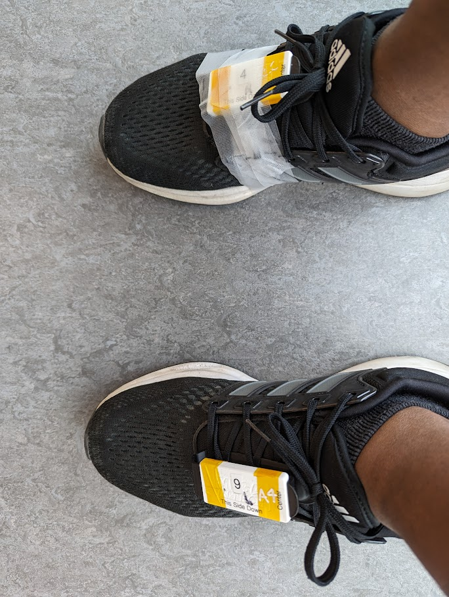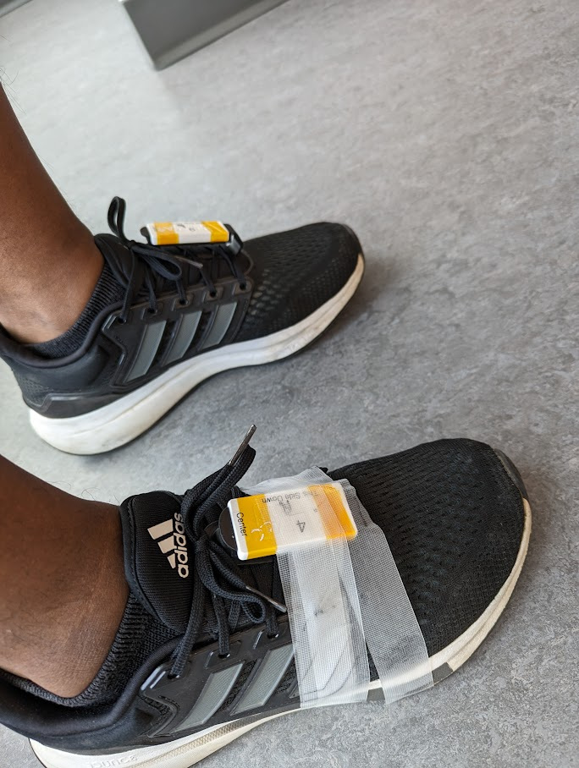

Data acquired by both taped and non-taped data were compared and it improved drastically by taping the sensors down because a lot of noise was previously being generated by the wobbling effect of the clips.

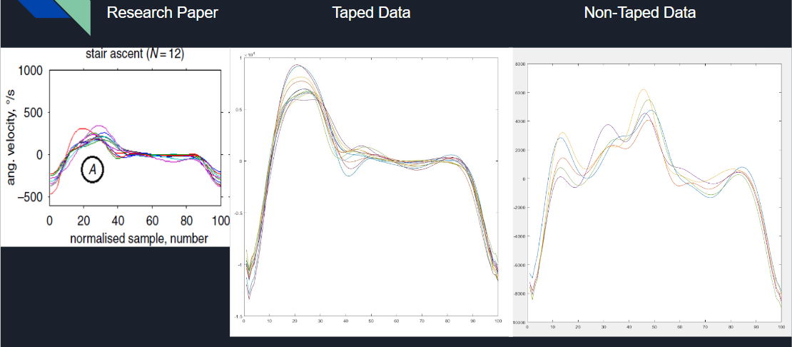

## Activity Classification Algorithm (ACA):

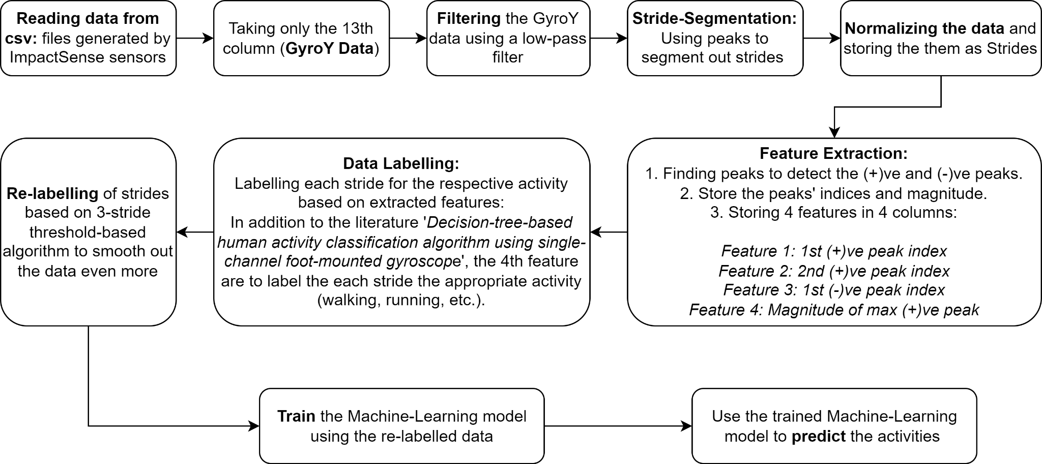

The flowchart above shows the main steps involved in the ACA. For the development of the algorithm the following steps were taken:

* Data Compilation and Labeling:   
  Developing a code to compile data from multiple participants and accurately labeling it was essential for subsequent analysis. This organized dataset was handed over to Ranjani for further processing.
  + 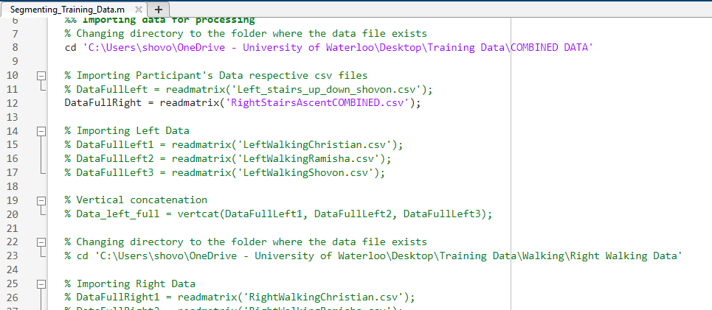The above script (Segmenting_Training_Data.m) is written for the following purposes:
  + Segmenting specific sections of the data for each of the activities (walking, stairs ascent, etc.).
  + Compiling segmented data from multiple participants into a compiled dataset for each of the activities.
  + Adding a column with labels for each of those COMBINED datasets
  + Later on, those datasets are used to train machine learning models on Python by Ranjani.
* Peak Parameter Optimization:   
  Tuning the parameters for peak detection to match the characteristics of the new sensors was vital for accurate activity recognition.
* Filtration Enhancement:   
  Improving data filtration to reduce noise contributed to more precise stride segmentation and better peak detection results. Besides that, the design and implementation of filters in Python to replicate MATLAB results were essential for ensuring consistency in the analysis and results between the two platforms.
* Magnitude as a Feature:   
  Utilizing the magnitude of sensor data as a feature for distinguishing between different activities, such as stairs ascent and running, was a significant enhancement in algorithm accuracy.
* Threshold-Based Activity Transitions:   
  Designing a threshold-based system to smoothly transition between activity classes required careful consideration and testing to ensure seamless activity recognition.
* Threshold Adjustment:   
  Successfully lowering the activity change threshold from the initial suggestion of 4-strides to a more efficient 3-stride threshold improved the algorithm's responsiveness and accuracy in recognizing activity changes.
* Result Comparison:   
  Conducting comprehensive result comparisons after training the model helped in fine-tuning and optimizing the algorithm's performance. Some of the parameters that were checked during comparison of results:
  + Total number of strides detected accurately
  + Magnitude of the peaks (both positive and negative) in the strides
  + Number of strides having the activities accurately recognized